Name of Student:
Name of the tutor:
Name of the Course:
Date:
The Formal Analysis and Critic of Caravaggio’s painting, The calling of St Mathew assignment
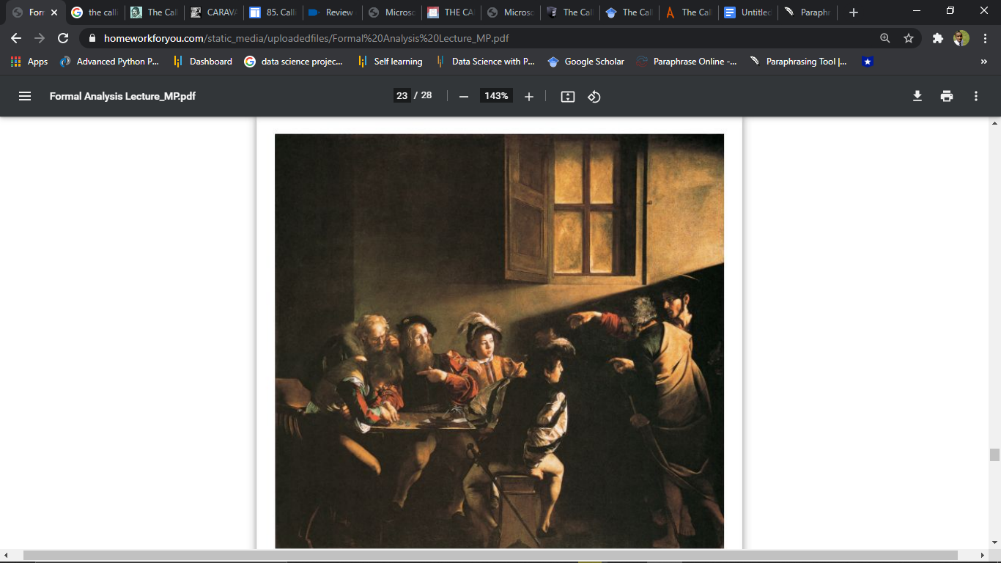
The calling of St Mathew (Majestic work, oil on canvas, 322 x 340 cm.) is a famous and cherished masterpiece painting done by Caravaggio, one of the most respected and famous artists of the Seventeenth Century. The painting was painted between the years 1599 to 1600. The painting shows the scene when Jesus Christ inspires a tax collector named Mathew to follow him and encourages him to become one of his disciples. The painting was commissioned as part of Cardinal Matthew Contarelli's will, which included funds and specific instructions for the decor of a cathedral inspired by Matthew's life. The painting was painted for the Contarelli Chapel in the cathedral in Rome, where it remains on display currently. In keeping with his plain, unfiltered visuals, Caravaggio reuses from his earlier genre paintings and sets the stage to look like what seems to be a pub rather than a counting building or workplace.
He brings some really vivid human interaction into the mix. To begin, Levi makes a motion as if to say "Me?" when he notices Christ pointing at him, indicating his uncertainty as to whether he is being discussed or not. Matthew's call shows the verse that is from the bible in the Gospel of Matthew when Jesus came to his house. Matthew stood and walked alongside him, as per the writings of the script. Christ (on the right, behind Peter) gestures to Mathew, the tax-collector (the bearded man wearing a hat), and asks him whether he wants to become one of his disciples, Matthew. Despite Levi's position on the far left of the picture, this painting contains elements that are very typical of the Baroque period, including drama, religious scenery, and a strong light and dark contrast. The religious scenery is unique since Caravaggio has placed this moment of Matthew's life in a typical ancient Roman tavern, which is surrounded by contemporary figures. This drama is created by the contrast of the local people with the figures of Jesus and St. Peter who are wearing historical garments. The drama is further highlighted by the deep darkness in the majority of the painting, with light that shines directly on Matthew. The light passes by the open window, crosses the chamber and illuminates a large portion of the back of the wall, and lights up Matthew and his closest associates' faces. Jesus' right arm helps the forward movement and the spirituality of the light, as it lifted and pointing towards Matthew. The room is almost completely dark on the left side of the painting behind Matthew and his companions. The viewer has no idea of the room's size and shape or if others exist. This state of darkness creates an emotional and spiritual drama inside the work. The composition of the painting can be categorized into two parts. One of the parts is the characters form a vertical rectangle on the right side, while in the second part, a horizontal block is formed on the left. The clothes on both sides, as well as Christ's symbolic hand, are further distinguished. Caravaggio uses a vibrant color palette, with bold contrasts of reds, gold, and greens, as well as various velvet and soft fur structures, to bring this artwork to life. Caravaggio also illustrates gestures, body movements, and facial expressions.
This image is split into two parts, as stated above in this work. A vertical rectangle is formed by the standing figures on the right; a horizontal block is collected around the table on the left. The outfits strengthen the contrasts of the bare-footed Christ. St Peter, who summon Levi into another world, appears in timeless coats. Matthew and his subordinates are clothed in a contemporary mode. The upper light illuminates both the face of St Matthew and the group of people who are assembled. Both groups are literally and symbolically bridged by Christ's hand, separated also by a void. The scene takes place in an ancient Roman setting of a pub or a tavern. This table group could actually be a scene of the artist's actual life. Also, the painting brings some real human interaction into the mix. To begin, Levi makes a motion as if to say "Me?" when he notices Christ is pointing at him, indicating his uncertainty as to whether he is being discussed or not. The ray of light shining on their faces attracts attention to two young men, who seem to be out of place among the elderly men. Although one recoils in terror and looks to his older friend for protection, the other man has turned to look Christ directly on the face, causing Peter to make a powerful expression of relaxation.

